# oled display string

## 一、Learning objectives

In this course, we will learn how to use stm32f103c8t6 to control Oled

display strings.

## 二、Preparation before class

The hardware that needs to be used is several Dupont lines,

stm32f103c8t6 development board, and 12832oled screen.

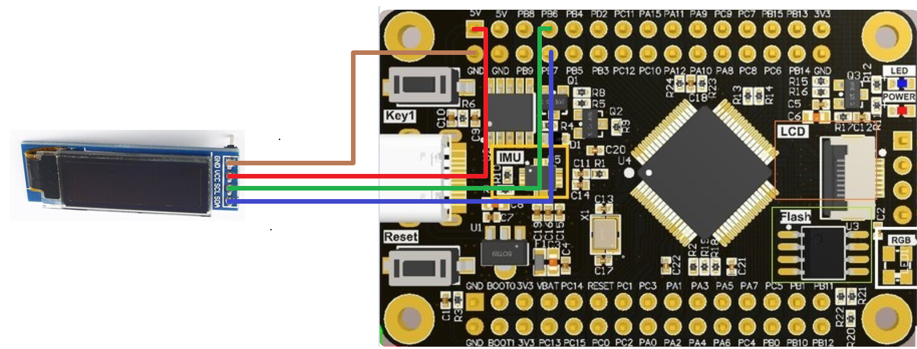

## 三、Code Interpretation

1. Initialize the IIC pins PB6 and PB7 to be used

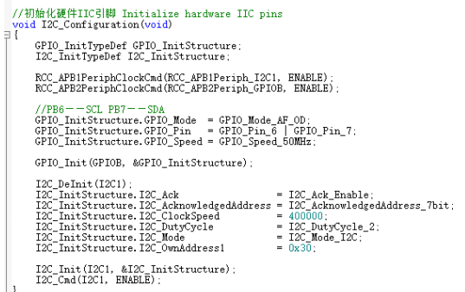

1. String display function usage

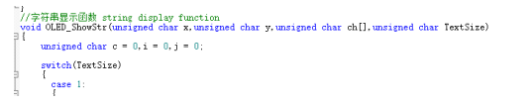

1. Main function

Initialize hardware gpio, delay, display string

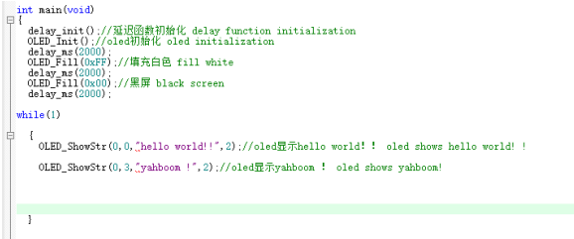

## 四、Experimental phenomenon

After compiling the source file and uploading it to stm32, oled will

display the string, as shown below

